TABLE OF CONTENTS

Page Number

1. **Introduction** 1

1.1 **About** 1

1.2 **Users** 1

1.3 **System Requirements** 1

2. **Getting Started** 2

2.1 **Logging In** 2

2.2 **Home Page** 3

2.3 **Profile Menu** 3

3. **User Management** 4

3.1 **Create/Modify Users** 4

3.2 **Delete Users** 6

3.3 **Change Password** 6

4. **Card Management** 7

4.1 **Create/Modify Cards** 7

4.2 **Search Cards** 9

4.3 **Delete Cards** 9

5. **File Generation** 11

5.1 **Add Cards** 11

5.2 **Remove Cards** 11

5.3 **Generate File** 11

6. **Troubleshooting** 13

6.1 **User Management** 13

6.2 **Card Management** 13

Introduction

**About**

Midwestern State University Card Services is a program designed to combine Midwestern State University student identifications with their respective Wells Fargo® banking account. In coordination with Wells Fargo®, students are able use their card as their Midwestern State University identification card and as a Wells Fargo® banking/debit card.

This website is designed to provide Midwestern State University Card Services administrators with an easy-to-use graphical interface. All functionalities of this website meet all requirements of the users and administrators. These requirements include: create a student identification card, generate a new student profile, modify existing student profile, edit image of student profile, and browse all existing student profiles.

**Users**

The users of this website are the employees and administrators at the Midwestern State University Information Desk and the faculty member in charge of the development of this website. The users will interact with the system to complete all functional requirements. The users are the primary actors in all use cases for this website. The primary actors are those who interact with the system on a daily basis and with the customer. The daily users include the student assistant at the information and the full-time employees of the Midwestern State University Information Desk.

**System Requirements**

Administrators and users of this website are encouraged to access this website through the following web browsers: Google Chrome version 56.0.2924.76 or later, Mozilla Firefox 51.0 or later.

Getting Started

This section contains an overview of basic site navigation features, logging in, the Homepage, and the Profile menu.

**Logging In**

To begin using the Card Services app, you will need to obtain a username and password from the system administrator. Once this is done, navigate to the Card Services URL at cs.mwsu.edu/cardservices in a supported browser. You will then see a login page as shown in Figure 1.

**Figure 1. Login Page**

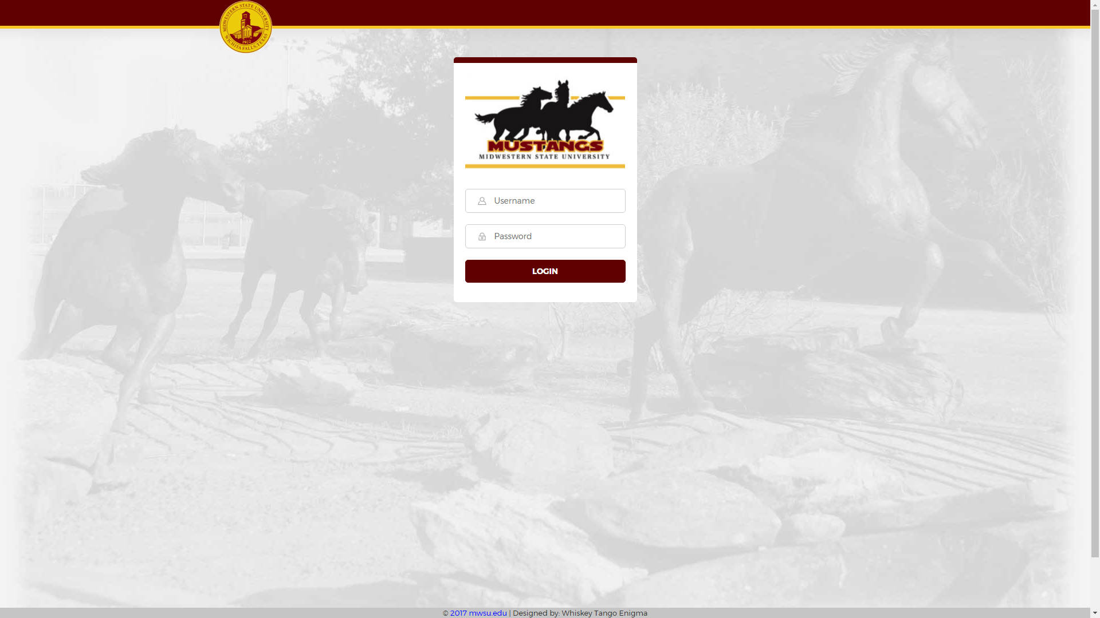

To log in from the login page, input your username and password into the appropriate fields and click the login button. If the username and password you input were valid, you will then be redirected to the home page as shown in Figure 2.

**Homepage**

From the homepage, you can navigate to the pages for creating, modifying, and browsing cards, as well as modifying card images and generating card files. To navigate to a page, simply click on its name in the top bar, or the appropriate icon in the main portion of the page.

**Figure 2. Homepage & Profile Menu**

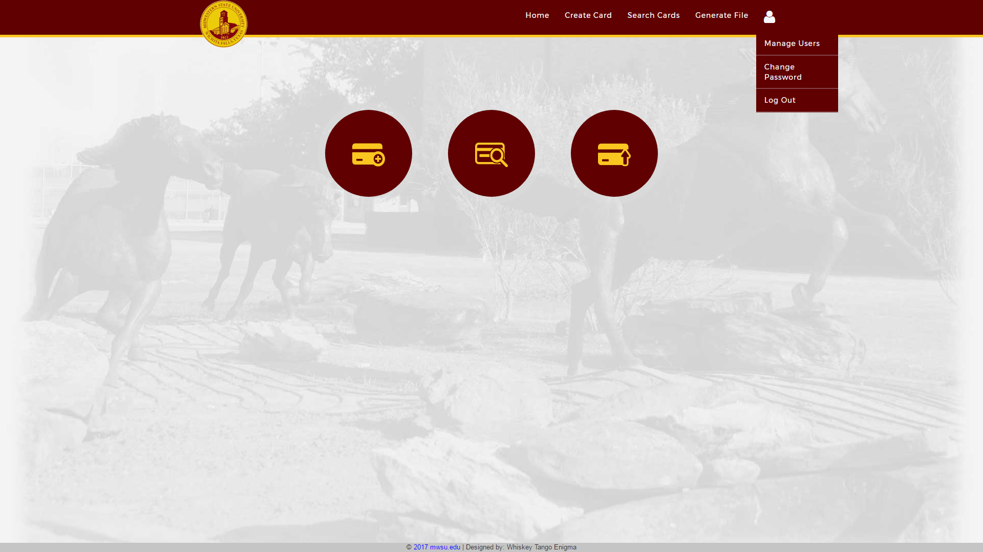

**Profile Menu**

To access the Profile menu (shown in Figure 5.) click on the User Profile button in the upper right of any page. From the profile menu you can create or modify existing users (if you are logged in on an approved admin account), change your password, or log out of the system.

User Management

This section contains instructions on how to create, modify, and delete users as an administrator, as well as instructions for users to change their passwords.

**Create/Modify Users**

To create a new user or modify existing users, click on the User Profile button in the upper right corner on any page, then select “Manage Users” from the drop-down menu (this option will only appear if you are logged in on an authorized admin account). This will open up the Users page as shown in Figure 3.

To modify an existing user, select the Modify User button next to their name. This will open up the Edit User page shown in Figure 4.a

To create a new user, select the Create User button at the bottom of the table. This will open up the Create User page (functionally identical to the Edit User page shown in Figure 4.a)

If you are creating a new user, all fields will be blank. On the personal details tab (shown in Figure 4.a) fill in the user’s first name, last name, and email address, then click the Proceed button to continue to the account info tab (shown in Figure 4.b.) On the account info tab, fill in the user’s username, and password, confirm their password, and select whether or not they are to be given admin permissions, then click the Submit button.

If you are modifying a user, all their current information will be filled in except for their password. Change whichever fields need to be changed and click the Submit button to update their info. (note: the users password will not be changed if these fields are left blank, and it is not necessary to fill out these fields to update user information)

**Figure 3. Users Page**

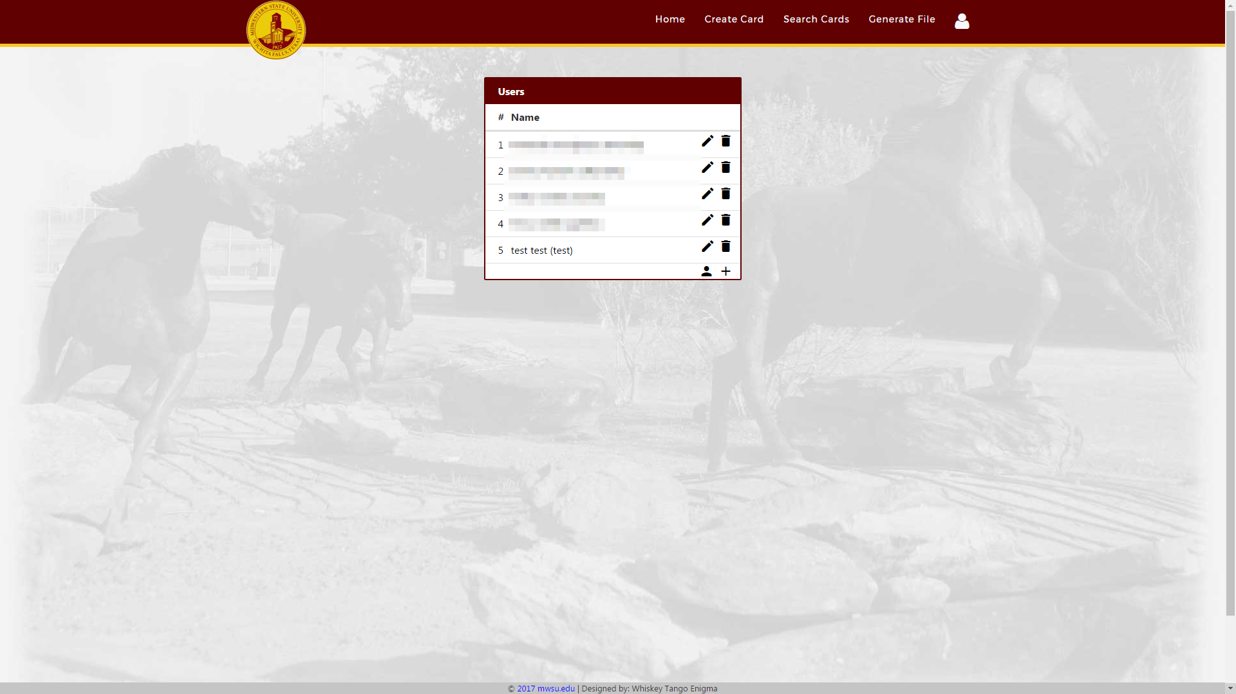

**Figure 4.a Edit User Page – Personal Details Tab**

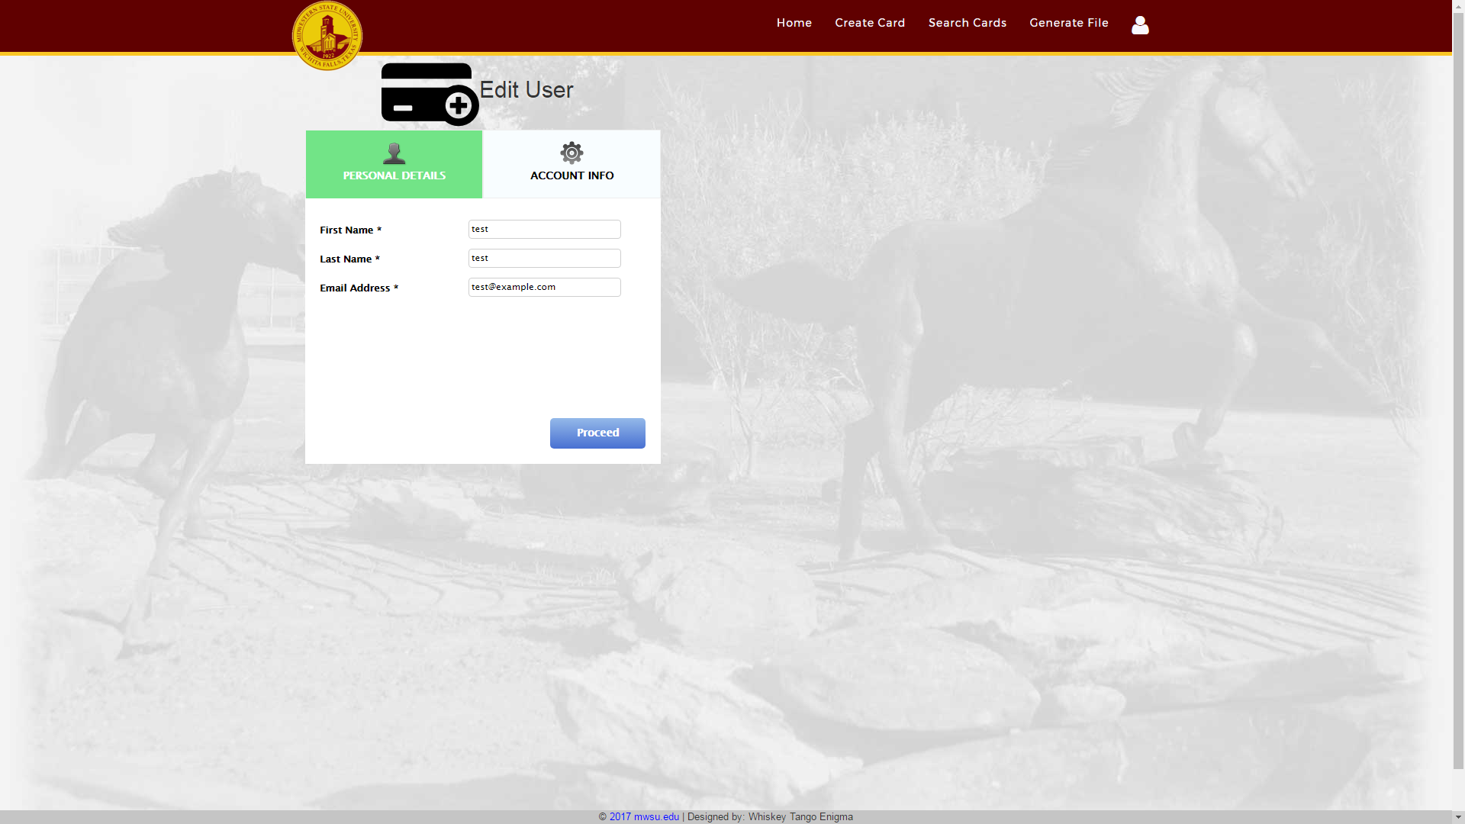

**Figure 4.b Edit User Page – Account Info tab**

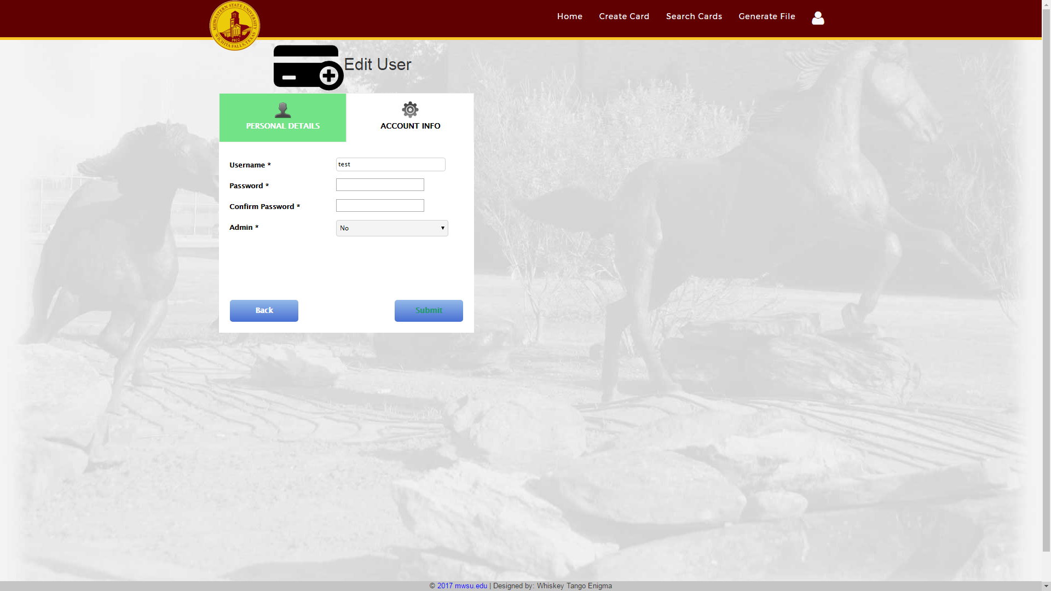

**Delete Users**

To permanently delete a user, click on the User Profile button in the upper right corner on any page, then select the Manage Users option from the drop-down menu. This will bring you to the Users page shown in Figure 3. From the users page, click on the Delete User button next to the name of the user you want to delete. You will then be prompted to confirm that you actually want to delete the selected user. Once a user has been deleted they cannot be recovered, so use this feature carefully.

**Change Password**

To change your password, click on the User Profile button in the upper right corner on any page, then select “Change Password” from the drop-down menu. This will open up the Change Password page as shown in Figure 5. Fill in your current password in the top box, your new password in the next two boxes, and click the Submit button to change your password.

**Figure 5. Change Password Page**

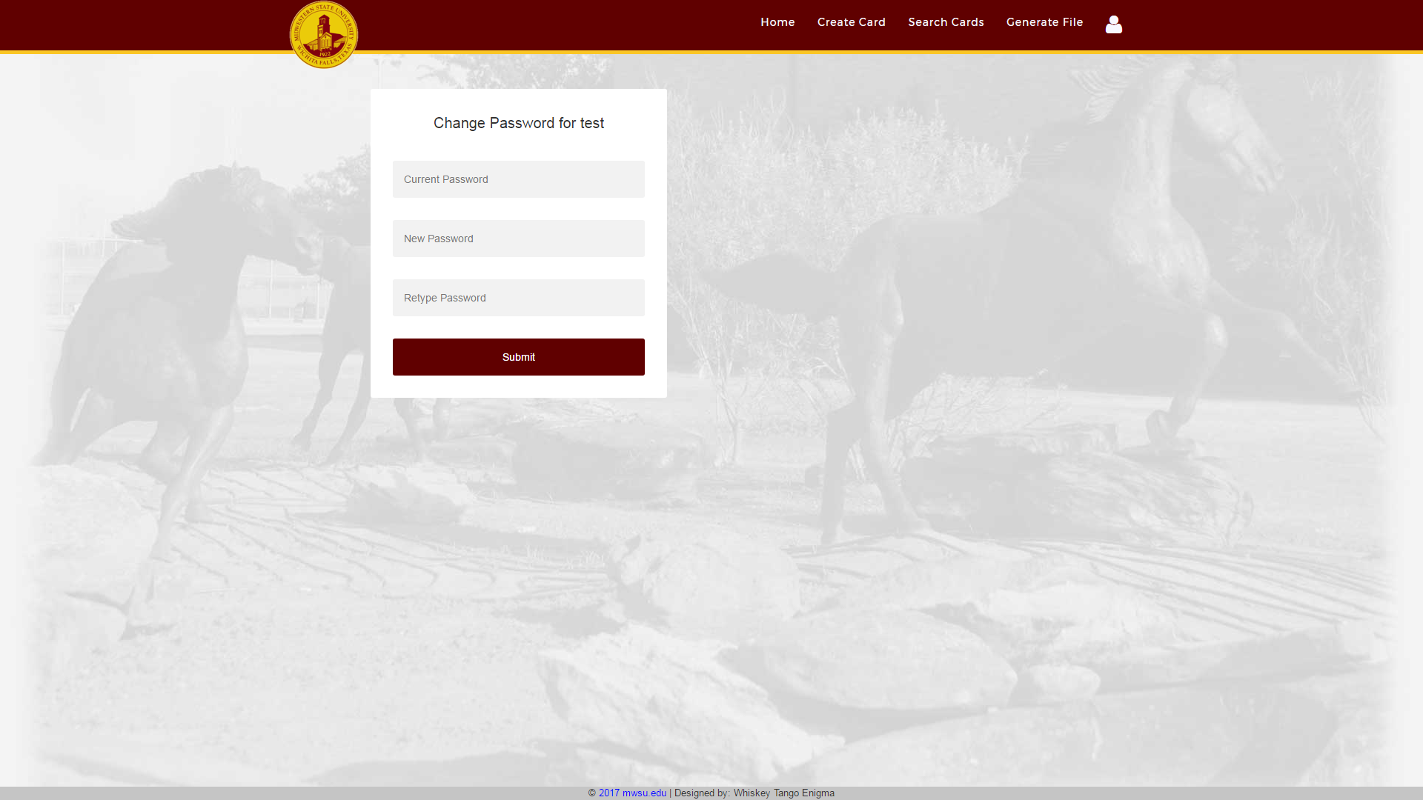

Card Management

This section contains instructions on creating new cards, modifying existing cards, using the Search Cards function, and deleting cards.

**Create/Modify Cards**

To create a new card, click the Create Card button on either the homepage or the navigation bar at the top of each page. This will bring open up the create card page shown in Figure 6.a.

To modify an existing card, find it with the Search Cards feature, click the Edit Card button, and select Edit from the drop-down menu. This will open up the Edit Card page (functionally identical to the Create card page shown in Figure 6.a.)

**Figure 6.a Create Card Page – Personal Details Tab**

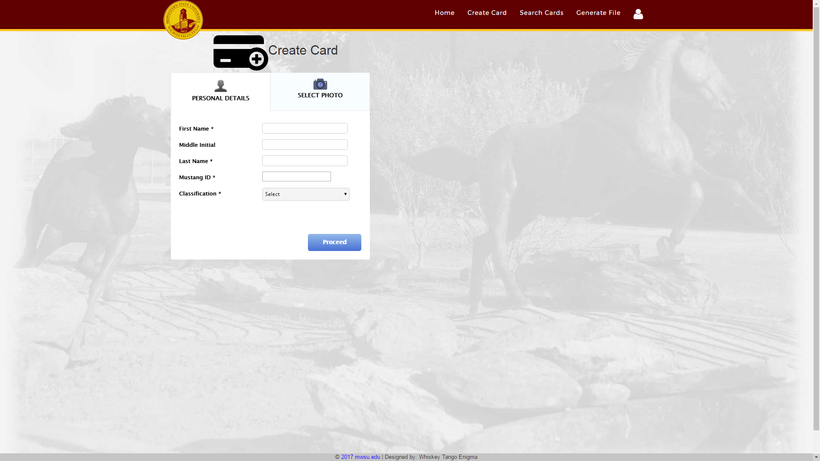

If you are creating a new card, all fields will be blank. On the Personal Details tab (shown in Figure 6.a) fill in the user’s first name, middle initial (optional), last name, and M-number (without the leading “M”), and indicate whether this card is for a faculty member, staff member, or student, then click the Proceed button to continue to the Select Photo tab (shown in Figure 6.b.) On the Select Photo tab, click on the Choose File button. This will open a browse dialog to allow you to select the students’ photo from your PC (note, this dialogue may differ in appearance from the one shown based on your browser and/or operating system). Navigate to the folder containing the student’s photo, select it, and click the Open button. Center the student’s face by dragging the photo within the window, and zoom in or out as necessary using the Zoom bar at the bottom of the page. Once all information has been filled in and the student’s photo has been properly sized and centered, press the Submit button to create the card

If you are modifying a card, all the current information will remain filled. Change whichever fields need to be changed and click the Submit button to update the card info.

**Figure 6.b Create Card Page – Select Photo Tab**

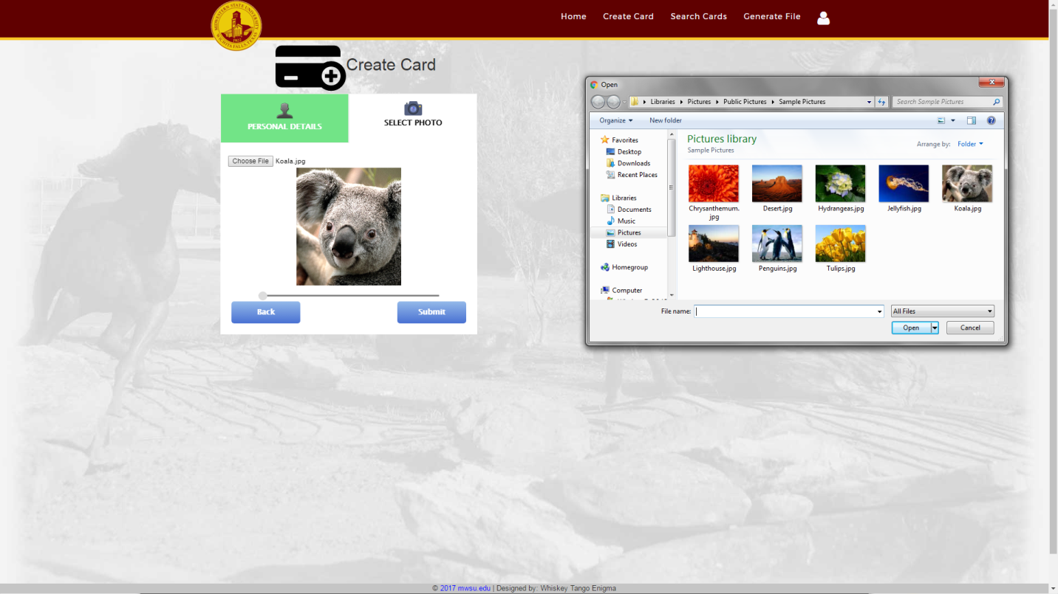

**Search Cards**

To search for a card or group of cards, click on the Search Cards button on either the homepage or the navigation bar at the top of each page. This will bring you to the Search Cards page shown in Figure 7.a. From this page enter your search query in the search box, and click on the Search button. This will search the names and M-Numbers of all cards in the database and show you all cards which contain matches for your query. If more cards are found than will fit on one page, you can navigate to the other pages using the navigation buttons at the bottom of the page.

If you wish to browse all cards, click the Show All button to bring up every card in the database.

**Delete Cards**

To permanently delete a card, find it with the Search Cards feature, click the Edit Card button, and select Delete from the drop-down menu. You will then be prompted to ensure you want to delete the selected card. Once a card has been deleted it cannot be recovered, so use this feature carefully.

**Figure 7.a Search Cards Page – No Cards**

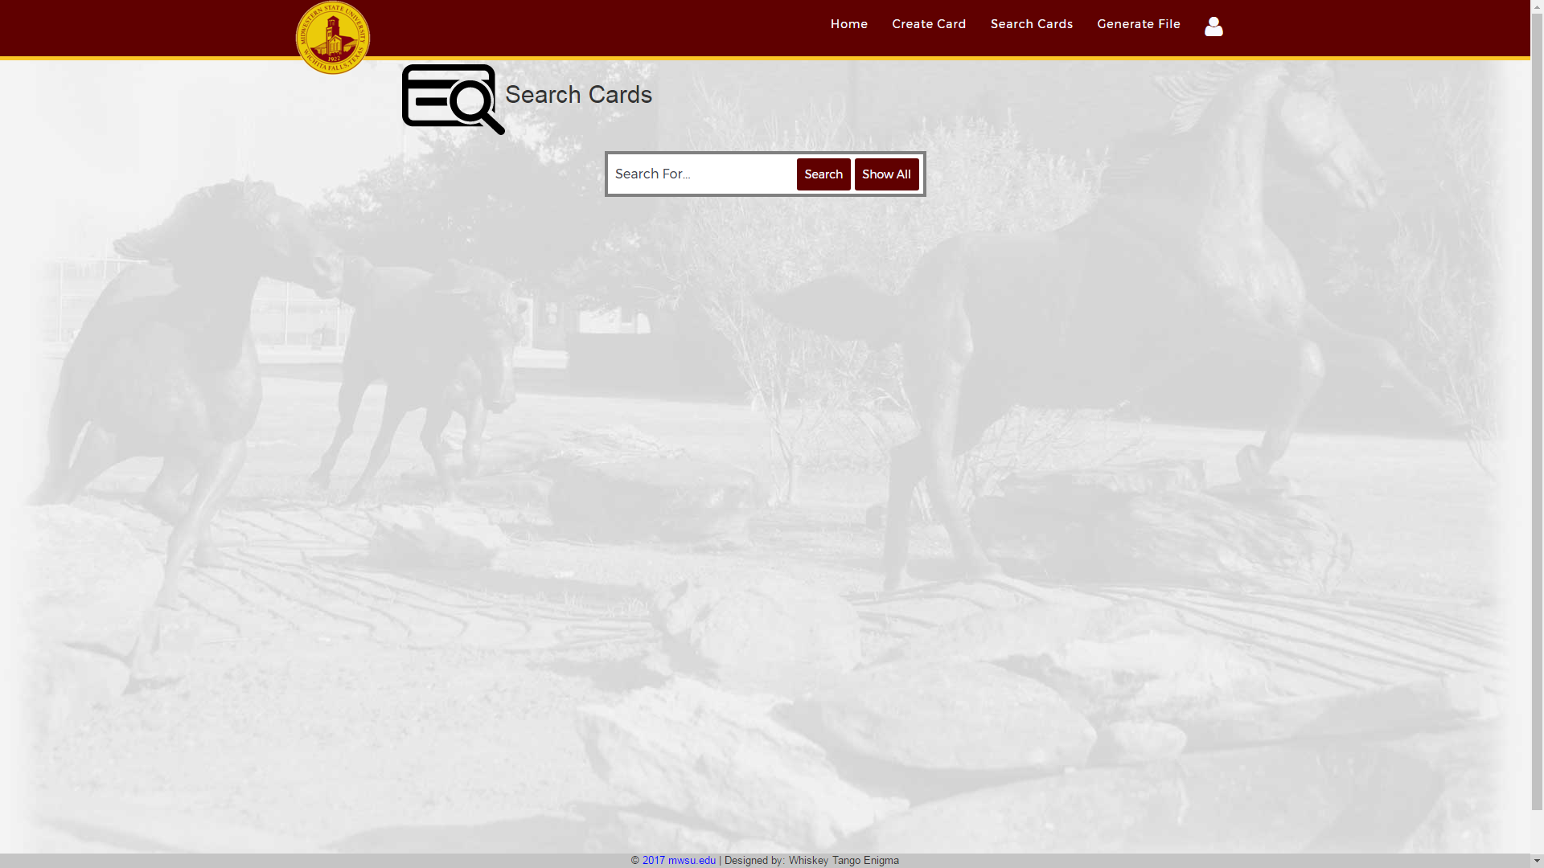

**Figure 7.B – With Cards**

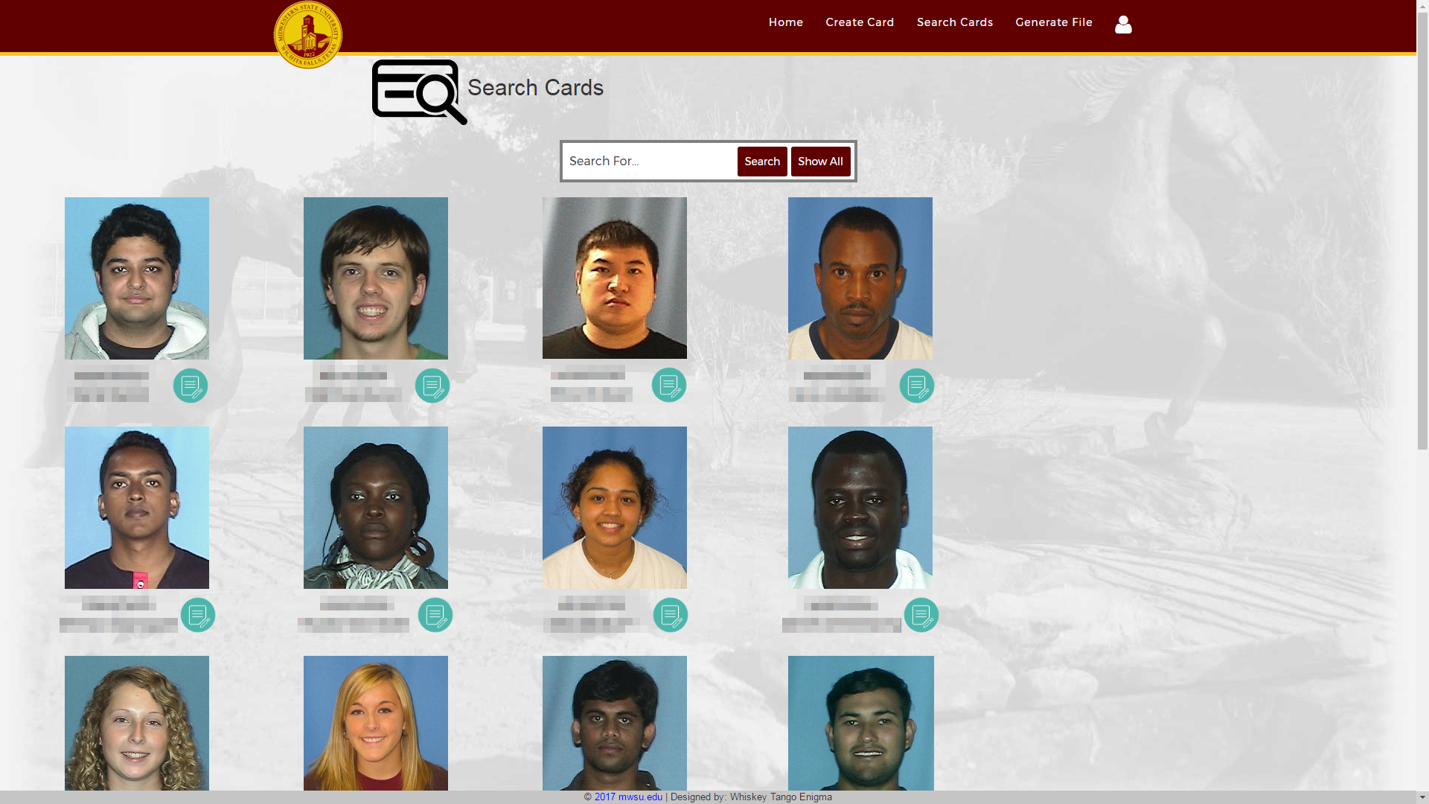

File Generation

This section contains instructions for adding cards to the cart for file generation, removing cards from the cart for file generation, and generating card files.

**Add Cards**

To modify an existing card, find it with the Search Cards feature, click the Edit Card button, and select Add to File from the drop-down menu. This will open up the Add Card dialogue. Confirm that the M-number shown is correct and select the appropriate card status, then click the Add to Cart button to add the selected card to the cart.

**Remove Cards**

To remove a card from the cart, click on the Generate File button on either the homepage or the navigation bar at the top of each page. This will bring you to the Generate file page shown in Figure 8. Click the Edit Card button, and select Remove from the drop-down menu. This will open a dialogue confirming that you want to remove the selected card from the cart. Click on the Yes button to remove the selected card from the cart.

**Generate File**

To generate a file, click on Generate File button on either the homepage or the navigation bar at the top of each page. This will bring you to the Generate file page shown in Figure 8. Click on the Generate File button. This will generate a card file and open a dialogue to download it to your PC.

**Figure 8. Generate File**

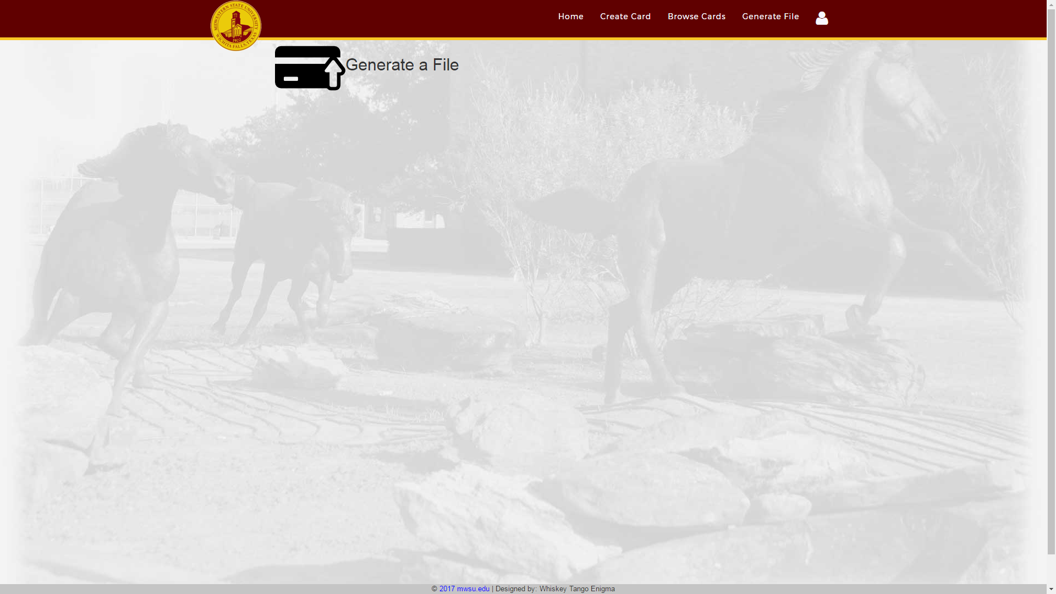

Troubleshooting

This section contains information on common errors or unexpected behavior that may arise during the use of this program.

**User Management**

The User Profile button may not respond to clicks in the white area. If this issue arises, it can be worked around by clicking in the maroon/gold area of the User Profile button.

**Card Management**

When adding a card to the cart, the page may respond with “This card is already in the cart” when the selected card is not visible in the cart. This is likely caused by the card being in another user’s cart.